Sophia Genetics: Data Engineer Report
Kieron Ellis

Database design

The entity relationship model used is based on the star schema containing one fact table and one dimensions table as seen below.

What is star schema
Benefits of using star schema
Why use star schema here
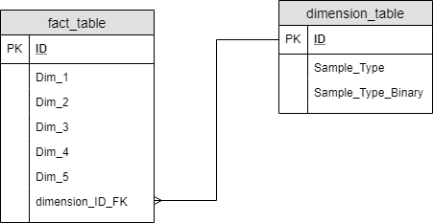

Dimension table
The dimension table contains 3 fields: sample type binary, sample type, and an auto incrementing integer primary key field called ID. This table contains all of the unique combinations of sample type and sample type binary values present in the raw data table.

Fact table
The fact table contains the 5 principle component fields (dim 1, dim 2, … , dim 5), an auto incrementing integer primary key field called ID as well as a foreign key pointing to the ID field of the dimensions table called dimension_ID_FK.
The sample field from the raw data was dropped in favour of the auto incrementing integer primary key field. The reason for this is that keeping the sample field as a string format (e.g. “Sample 1”) increases the file size of the table and will slow down both writing to and reading from the table.
There is a one-to-many relationship between dimension_table.ID and fact_table.dimension_ID_FK.

What does one to many mean

Why use it here - to reduce the size of the dimension table.

Indexing

Deployment and ETL
Due to the limited direction given in the background and explanation of the dataset as well as the expectations, assumptions have to be made on setting up the database structure and designing an ETL pipeline to populate it.

I have made several assumptions:
- One such assumption I have made is due to the lack of timestamp/batch number/etc fields in the dataset, as well as the expectation that the dataset will increase to 10 million rows and additional dimensions of label assignments, I have assumed that this data is a subset of a single analysis.
- The full dataset when it is provided will replace the subset of data.
- The names of all quantitative fields (e.g. the Dim 1 PCA field) will always be called Dim followed by a number.

With this in mind, I have created an automated ETL pipeline without hardcoded SQL which will sort all quantitative fields into the facts table and all qualitative fields in to the dimensions table without requiring further tuning.

The pipeline is built using Python but queries a PostgreSQL database for all data operations, i.e. the raw data is not stored by Python in Pandas/a Numpy array at any stage of the ETL process.

The raw dataset is first ingested into a table called raw_data_table, which could be used to store it in a data lake. This raw_data_table is then queried to create the fact_table and dimension_table.

In order to query this data to return all of the fact and dimension fields the fact_table and dimension_table must be queried with a left outer join SQL query where the dimension_ID_FK matches the dimension_table ID. An example of such a query is shown below

SELECT *
FROM fact_table
LEFT JOIN dimension_table
ON fact_table.dimension_ID_FK = dimension_table.id

Data Analysis
##elbow method to determine optimal number of clusters in data for k-means algorithm
# Scale to give equal importance to all variables. Alternative method = StandardScaler

# For each k value, we will initialise k-means and use the inertia attribute to identify the sum of squared distances of samples to the nearest cluster centre.
Sum_of_squared_distances = []
K = range(1,15)
for k in K:
km = KMeans(n_clusters=k)
km = km.fit(data_transformed_continuous)
Sum_of_squared_distances.append(km.inertia_)

# optimal number of clusters = 6

# alternative method to determine optimal number of clusters (https://scikit-learn.org/stable/auto_examples/cluster/plot_kmeans_silhouette_analysis.html)
# Selecting the number of clusters with silhouette analysis on KMeans clustering

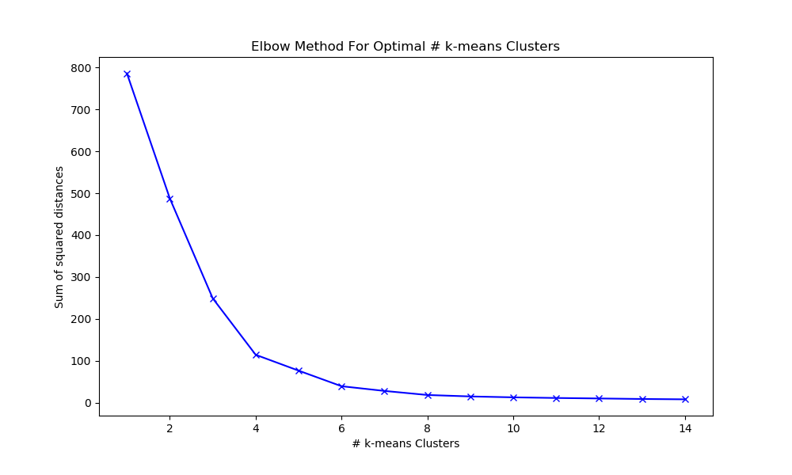

Data Visualisation
The interactive webpage can be seen at
https://public.tableau.com/profile/kieron4186#!/vizhome/SophiaGeneticsInteractiveDataAnalysis/GeneticsData

The dashboard includes 3 main sections:
- A count of the number of records in the dataset
- A count of the number of good and bad samples per sample type
- An interactive scatter chart where the x-axis, y-axis and colour can be selected by the user for self-service analysis.

The scatter chart is initially coloured by the k-means clusters from the Data Analysis above. As can be seen, this algorithm with 6 clusters as its input did a good job of segmenting the dataset into distinct clusters.

examples

